**Output (Screenshots)**

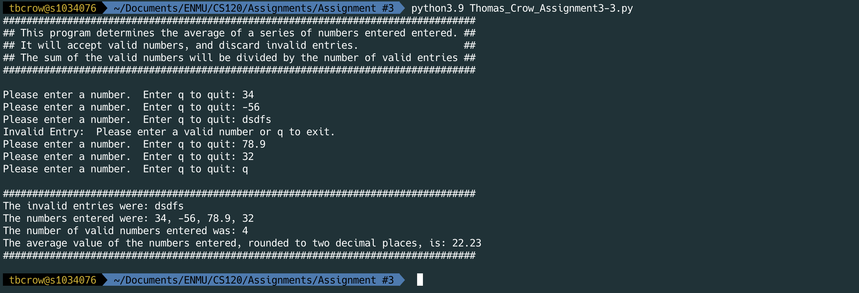

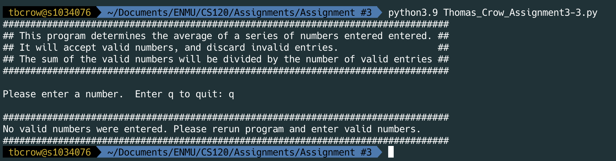

**Output (Copied and pasted)**

tbcrow@s1034076  ~/Documents/ENMU/CS120/Assignments/Assignment #3  python3.9 Thomas_Crow_Assignment3-3.py  ✔  120  17:36:10

#################################################################################

## This program determines the average of a series of numbers entered entered. ##

## It will accept valid numbers, and discard invalid entries. ##

## The sum of the valid numbers will be divided by the number of valid entries ##

#################################################################################

Please enter a number. Enter q to quit: 34

Please enter a number. Enter q to quit: -56

Please enter a number. Enter q to quit: dsdfs

Invalid Entry: Please enter a valid number or q to exit.

Please enter a number. Enter q to quit: 78.9

Please enter a number. Enter q to quit: 32

Please enter a number. Enter q to quit: q

#################################################################################

The invalid entries were: dsdfs

The numbers entered were: 34, -56, 78.9, 32

The number of valid numbers entered was: 4

The average value of the numbers entered, rounded to two decimal places, is: 22.23

#################################################################################

tbcrow@s1034076  ~/Documents/ENMU/CS120/Assignments/Assignment #3 

tbcrow@s1034076  ~/Documents/ENMU/CS120/Assignments/Assignment #3  python3.9 Thomas_Crow_Assignment3-3.py  ✔  121  17:40:15

#################################################################################

## This program determines the average of a series of numbers entered entered. ##

## It will accept valid numbers, and discard invalid entries. ##

## The sum of the valid numbers will be divided by the number of valid entries ##

#################################################################################

Please enter a number. Enter q to quit: q

#################################################################################

No valid numbers were entered. Please rerun program and enter valid numbers.

#################################################################################

tbcrow@s1034076  ~/Documents/ENMU/CS120/Assignments/Assignment #3 